**PROJECT DESIGN PHASE-II**

**TECHNOLOGY ARCHITECTURE**

|  |  |
| --- | --- |
| Date | 17 October 2022 |
| Team ID | PNT2022TMID51074 |
| Project Name | AI BASED DISCOURSE FOR BANKING INDUSTRY |

**Technical Architecture:**

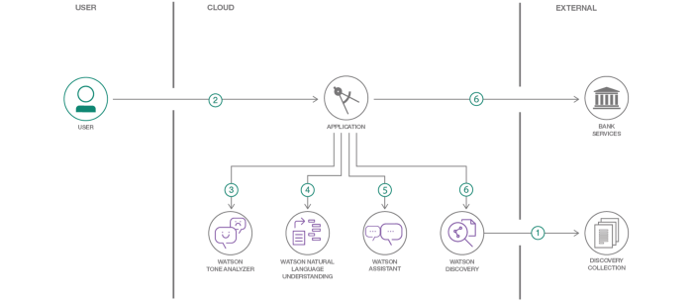

**Table-1 : Components & Technologies:**

|  |  |  |  |
| --- | --- | --- | --- |
| **S.No** | **Component** | **Description** | **Technology** |
| 1. | Bot Preview | As they have an easily accessible environment, a user interacts with the Bot to ask queries. | HTML, CSS, JavaScript |
| 2. | Application Logic-1 | On the Bot’s message bar, the user can type questions. | Python / IBM Watson Assistant |
| 3. | Application Logic-2 | Frequently Asked Questions (FAQ) could be used by users. | IBM Watson STT service |
| 4. | Application Logic-3 | Users can examine fresh updates and be alerted of recent additions from the bank. | IBM Watson Assistant |
| 5. | Cloud Database | Queries are predicted with solutions and stored in the cloud to be retrieved whenever they are needed. | IBM Cloud ant DB |
| 6. | External API-1 | It gives your client application runtime methods for sending user input to an assistant and receiving a response. | Watson Assistant v2 API |
| 7. | External API-2 | An on-premises and cloud-based enterprise-grade platform for developing, securing, controlling, sharing, monetizing, and analysing customized APIs. | IBM Cloud API |
| 8. | Deep Learning Model | It learns to execute classification tasks directly from text and achieves cutting-edge accuracy, sometimes outperforming human performance. | Deep Learning |
| 9. | Infrastructure (Server / Cloud) | On cloud server we will be deploying the chat bot using flask in the web page. | Python Flask |

**Table-2: Application Characteristics:**

|  |  |  |  |
| --- | --- | --- | --- |
| **S.No** | **Characteristics** | **Description** | **Technology** |
| 1. | Open-Source Frameworks | Open-source frameworks used is Python Flask | Technology used Python Flask |
| 2. | Security Implementations | End-to-end encryption of data, Isolation of customer data, Vulnerability scanning and intrusion detection, Antivirus and anti-malware protection, Security for user devices, Application of security patches. | SHA-256, Encryptions, IAM Controls, OWASP, IBM Watson Assistant etc. |
| 3. | Scalable Architecture | Chat bot architecture consists of four pillars. They are intents, entities ,data flow, scripts (3 – tier architecture –presentation tier, application tier, data tier and Micro services architecture) | Technology used –IBM Watson Assistant |
| 4. | Availability | The Bot is made available using load balancers, distributed servers etc. | Technology used –IBM Watson Assistant |
| 5. | Performance | IBM Watson –automate processes, The deep learning model is trained using IBM Watson studio for better performance | Technology used –IBM Watson Assistant |